[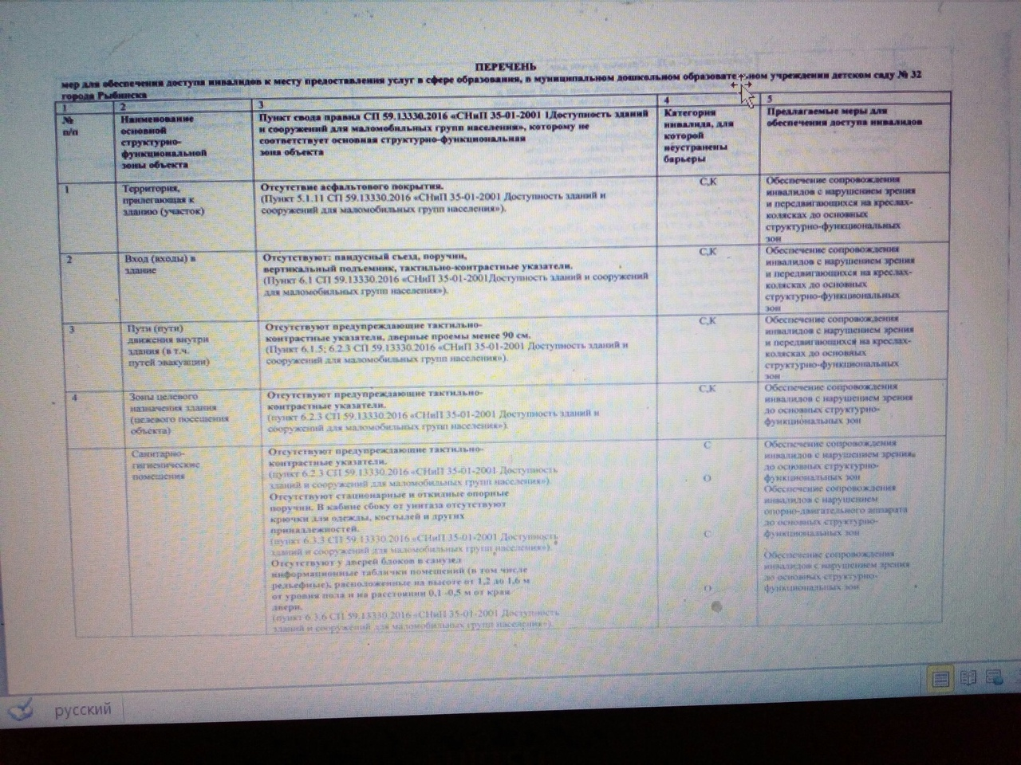](https://vk.com/photo115193577_456240288)

[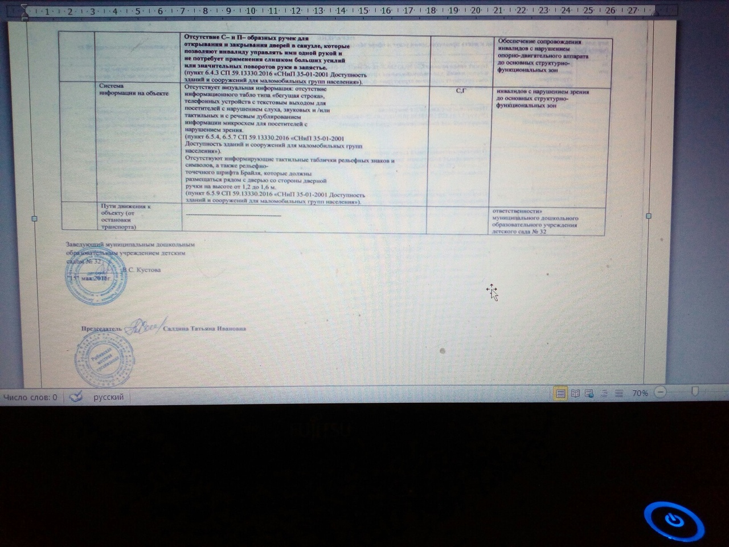](https://vk.com/photo115193577_456240289)